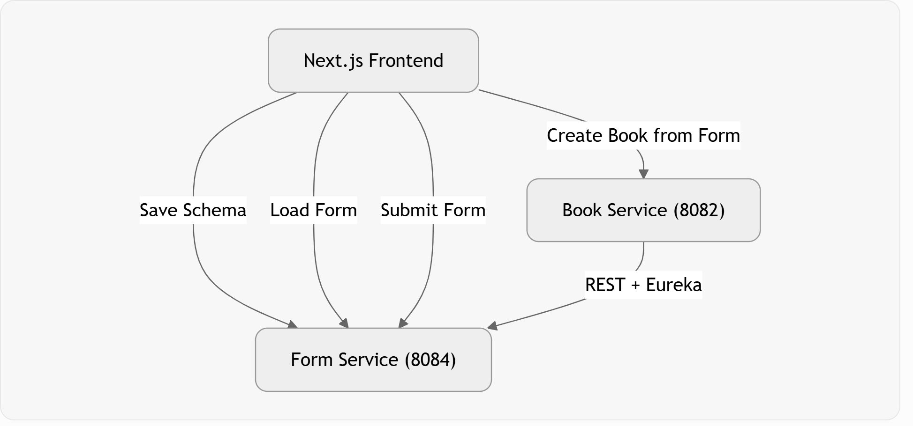

Form Service: Stores form definitions (FormSchema) and submissions (FormSubmission).
Book Service: Consumes forms (via FormServiceClient) and has smart mapping logic to turn any dynamic form into a Book entity.
Frontend: Has a custom dynamic builder (not Form.io in the final version) + custom renderer.

2. How the Dynamic Form Builder Works (Frontend)

Key Files:
- BuilderPage.tsx → Main page
- SimpleFormBuilder.tsx → The actual builder
- DynamicFormRenderer.tsx → Renders the form for users to fill
- lib/formApi.ts (assumed) → API calls to backend

Step-by-step flow when building a form:
- User clicks "Text", "Select", "Email", etc. → addField(type)
- Opens modal to edit:
  - Label (human readable)
  - Placeholder
  - Required
  - Options (for select/radio)
  - Advanced: Field Key (id) — very important for backend

- Schema structure created:
JSON
{ "title": "Book Registration Form", "fields": [ { "id": "field_1738901234567", "type": "text", "label": "Book Title", "placeholder": "Enter book title", "required": true }, { "id": "field_1738901239999", "type": "text", "label": "Author Name", "required": true }, { "id": "price_field", "type": "number", "label": "Price (USD)" } ]}
- "Save to Backend" button:
  - Calls saveFormSchema(title, JSON.stringify(schema))
  - Sends POST to FormService → /api/forms
  - Backend saves schemaJson as TEXT column

3. Spring Boot Backend — Form Service
Entity (FormSchema):
Java
@Column(columnDefinition = "TEXT")private String schemaJson;
private String schemaJson; // ← Full JSON saved here

Controller (FormController):
- POST /api/forms → Save new form
- GET /api/forms → List active forms
- GET /api/forms/{id} → Get one form (used by renderer)
- DELETE /api/forms/{id} → Soft delete

FormSubmission entity stores submitted data as JSON in submissionData.

4. Rendering & Submitting the Form
Flow:
- User goes to My Forms → clicks "Fill"
- ViewFormPage fetches form:
const form = await getFormById(id);const schema = JSON.parse(form.schemaJson);
- Passes to DynamicFormRenderer
- Renderer:
  - Loops through schema.fields
  - Renders correct input based on type (text, select, checkbox, file, etc.)
  - Uses field.id as the key in formData
  - On submit → sends { field_123: "Value", price_field: 29.99, ... }
This data goes to Form Service → saved in FormSubmission.

5. The Most Interesting Part: Book Service Integration
This is where your code becomes really smart.

Endpoint: POST /books/from-form?formId=5
What happens inside BookController.createBookFromForm:
- Gets the schema (either from request body or fetches from Form Service)
- Passes data + schema to FormFieldMapper.mapToBook(formData, schemaJson)
- Mapper does magic (this is the cleverest part):

How FormFieldMapper works (Flexible Mapping)
It tries multiple strategies to map form data to Book fields:

Key Strengths of This Implementation
- Schema-driven: Form definition and rendering are decoupled
- Flexible mapping: Handles messy real-world form data
- Microservices-friendly: Form Service is reusable across services
- Custom builder: Lightweight, no heavy dependency on Form.io (though you have Form.io components too)

General Pattern (How to Do It for Any Service)
- Create a new Spring Boot microservice (e.g., product-service).
- Add FormServiceClient (same as in Book Service).
- Create an Entity (e.g., Product).
- Create a smart mapper (ProductFieldMapper) — this is the heart of the magic.
- Add a controller endpoint: POST /products/from-form?formId=XX
- (Optional) Add standard CRUD.
- In frontend: Call this endpoint after filling a form.
The Form Service stays unchanged — it's the central reusable service.

